Most channel permissions tasks in vBulletin are done through the Channel Permissions Manager. The channel permissions tools are accessible through the Usergroups menu or the Channel Management menu.

<<<Insert a screenshot of the Usergroups menu and its submenus, with the Channel Permissions link highlighted.>>>

<<<Insert a screenshot of the Channel Management menu and its submenus, with the Channel Permissions link highlighted.>>>

The primary tool is View Channel Permissions, available on the homepage of the Channel Permissions Manager. Using this facility, you can edit permissions by channel.

<<<Insert a level-setting screenshot of the Channel Permissions Manager, View Channel Permissions section.>>>

Other functions include Permission Duplication Tools, Permissions Quick Editor, and Quick Channel Permission Setup.

<<<Insert a screenshot of the Additional Functions form on the home page of the Channel Permissions Manager.>>>

For detailed information about channel permissions tasks and functions, see <<<Doc link: Managing Permissions>>>.

Managing Forum Permissions
Managing your forum permissions is similar to editing global usergroup permissions, but allows more control. If you click Usergroups > Forum Permissions, you will see a screen similar to this:
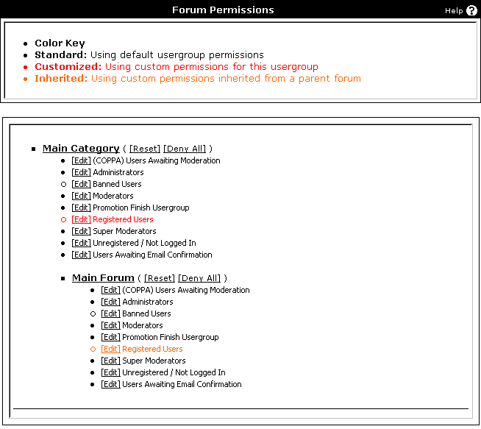
Here, you will see each forum on your board with a list of all usergroups under each forum. Notice the color key at the top. In this example, red indicates that a usergroup has a custom forum permission specified for this forum, while orange indicates that the group is inheriting a permission from a parent forum. Otherwise, no forum permission has been specified, so the group will be using its global usergroup permissions.

Next to each forum title, you will see 2 links:
- Reset – this will automatically delete any custom permissions that were set for this forum. It will not change any permissions that are being inherited from a parent forum.
- Deny All – this will automatically remove deny every usergroup access to this forum (every individual permission will be set to no for each usergroup). This is helpful if you want to deny access to a forum for most groups
To edit or add a forum permission, simply find the appropriate forum and usergroup, and click [Edit]. This will lead you to this screen:
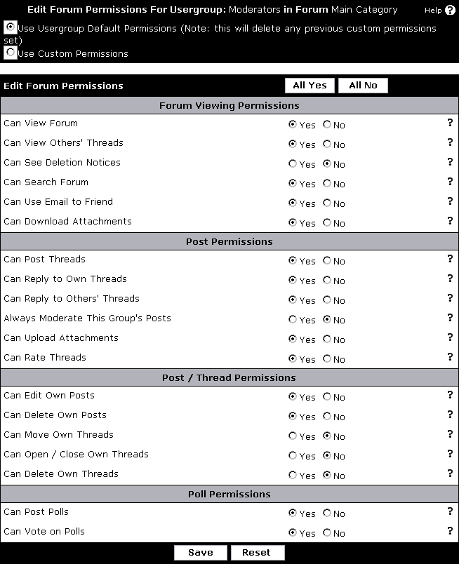
These permissions will likely look familiar to you because they are a subset of the options you can specify when editing global usergroup permissions. If you are unsure of what a specific option does, click the inline help icon for more information.
Note:
To delete a forum permission from this screen, make sure Use Usergroup Default Permissions is selected at the top of the page.

